DellKing Bluetooth Upgrade Wizard User Manual
Install the Bluetooth upgrade software interface and driver
A. Install the upgrade software interface
- Double-click the .exe installation package，Please Click“Next”.
- Select the installation path (default path :C:\Program Files\DellKing\Upgrade Wizard\...) And click “Next”.
- click "Install", the program is being installed... Please wait a moment.
- After the upgrade software interface is installed, click “Finish”.

B. Install the upgrade software driver
1) Pop up the dialogue box. Click “Next”.
2) Click "Install", the program is being installed... Please wait a moment.
3) Pop up the dialogue box below. Click “Finish”.

Now all steps of installation programme finished.

Upgrade Operation
- Double-click the shortcut of “Upgrade Interface” on the desktop. The dialog box below will be popped up. The default language is“English”(On this interface, please select the language you like. After selecting, every time you open, the upgrade interface will show the language you have selected. Click “Next”.
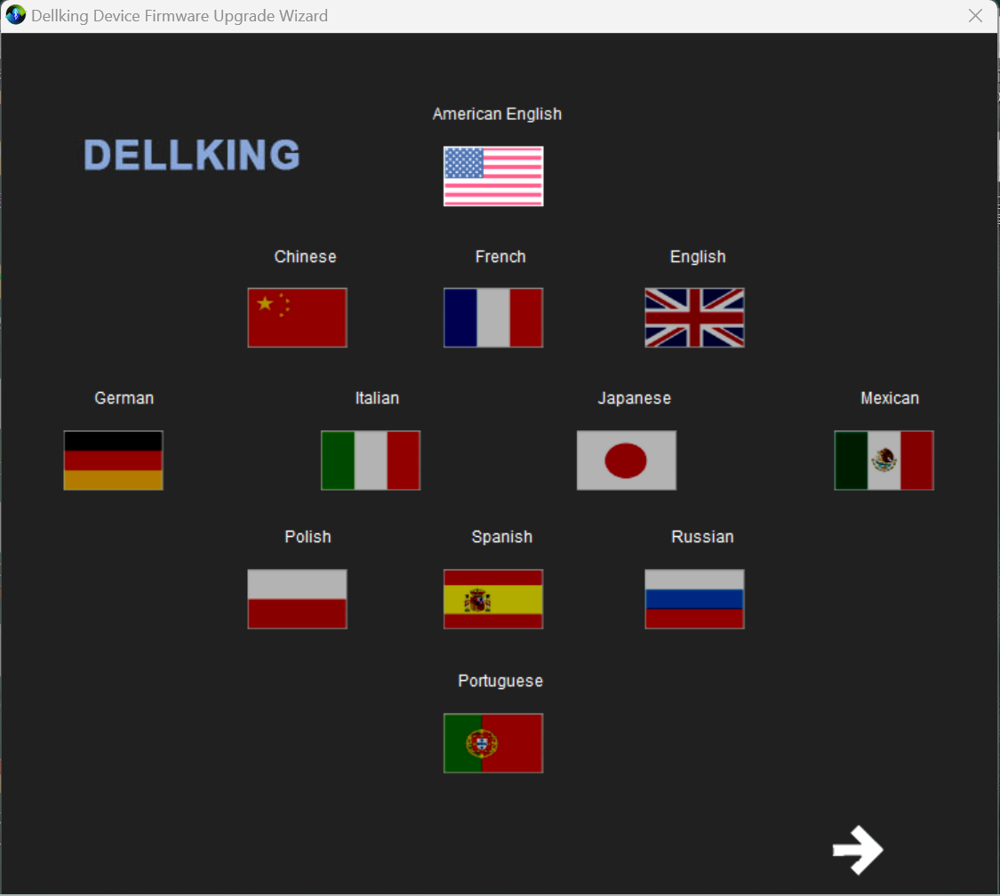
- The dialogue box below is displayed. For the version of the upgrade interface and the introduction of the company, etc., if the button of "Reconfigure display language" is "checked", it means that the "Language selection" interface will appear every time you open the upgrade interface; if "not checked", it means that the current selected language is remembered. And every time you open the upgrade interface, the "language selection" interface will not appear (if you would like to "re-select language" on this page, click the "Reconfigure display language" button "Check on", click the pop-up "back" button, select the language you like), click "Next".
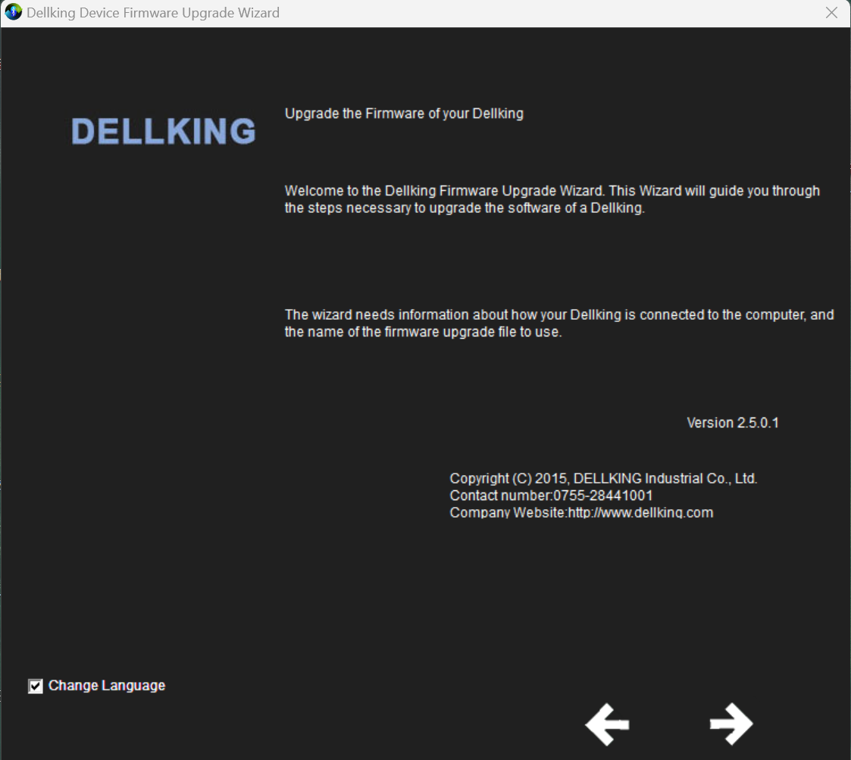
- In the following dialog box, connect the Bluetooth device to the PC through a USB cable, and make the Bluetooth device into the upgrade mode (the upgrade mode operation is as below). Then, select Universal Serial Bus (USB), and click “Next”
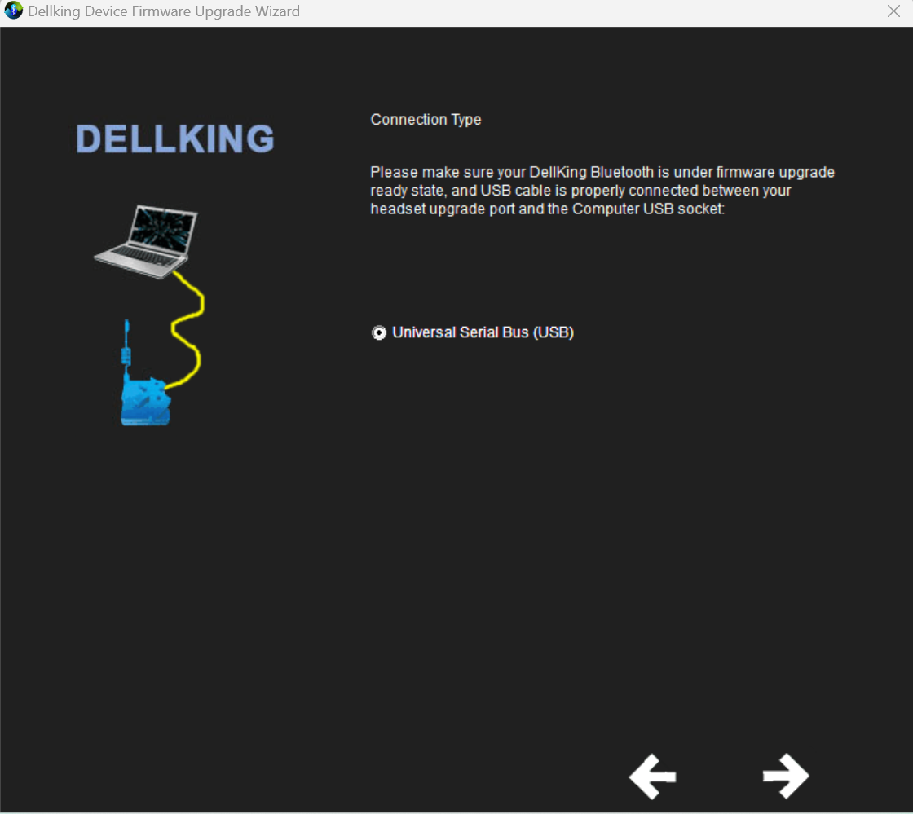
If not entering the upgrade mode, click “Next” button and the prompt dialogue box below will be displayed.
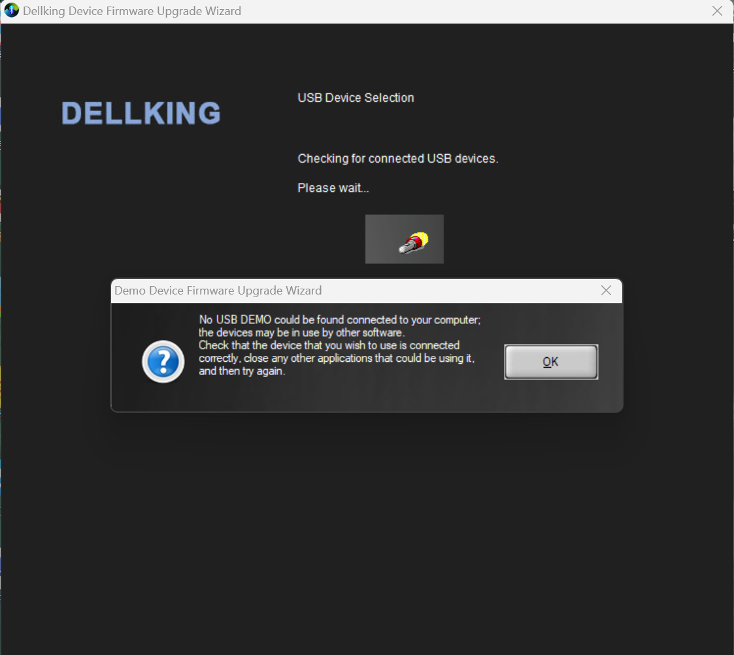

Make the Bluetooth device enter upgrade mode (the operation is as below:)
a.When the Bluetooth device connects with the computer, the initial state is as below (the red led light is flashing).
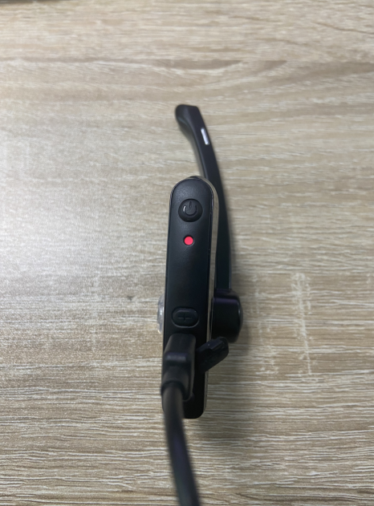

b. During this state, press and hold the Power Button and Volume + Button together until the red light off as below:
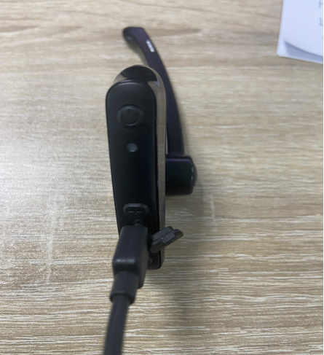

c. Click “Next” button and enter into next page.
Enter the upgrade process
- After that , a dialogue box pops up. Select “Device Firmware Upgrade” , Click“Next”.
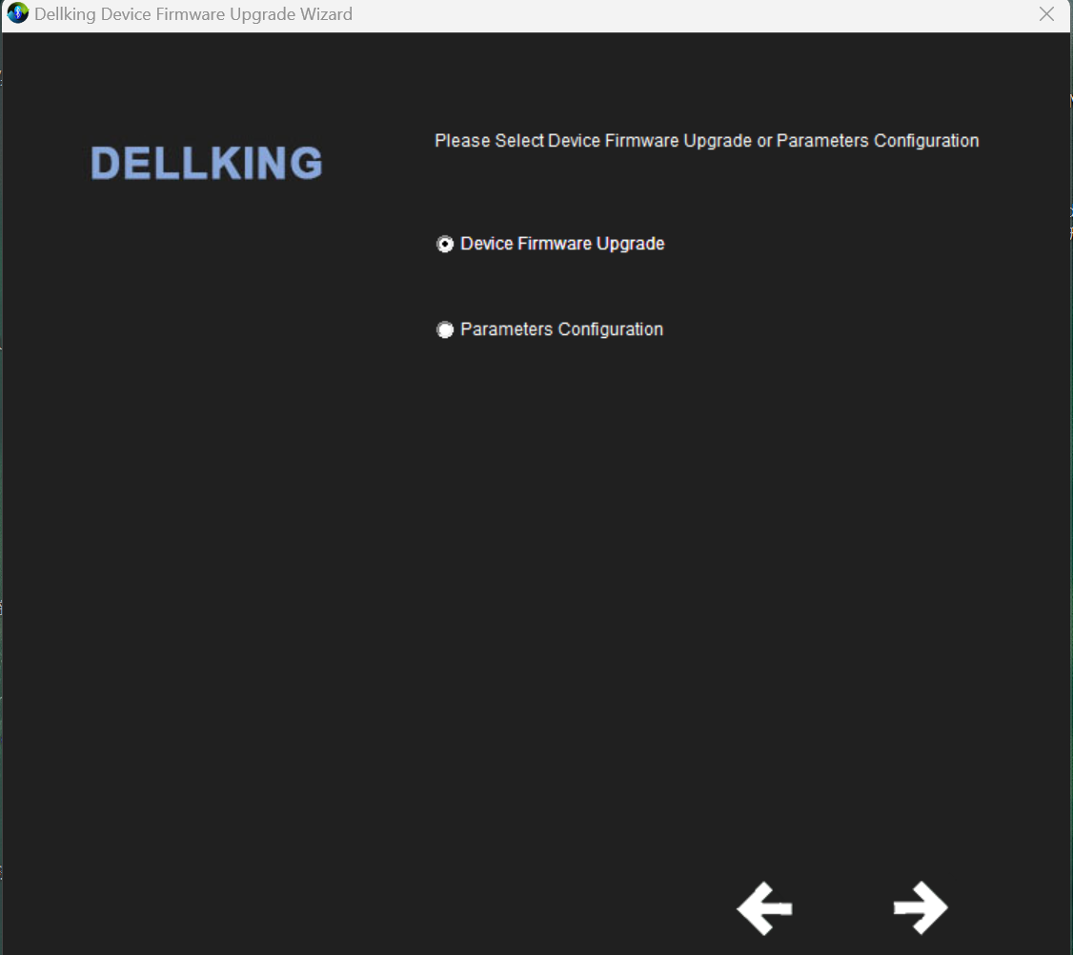
- A dialogue box pops up. Select “Download a new version of firmware, without first saving a copy of the current version” , Click“Next”.
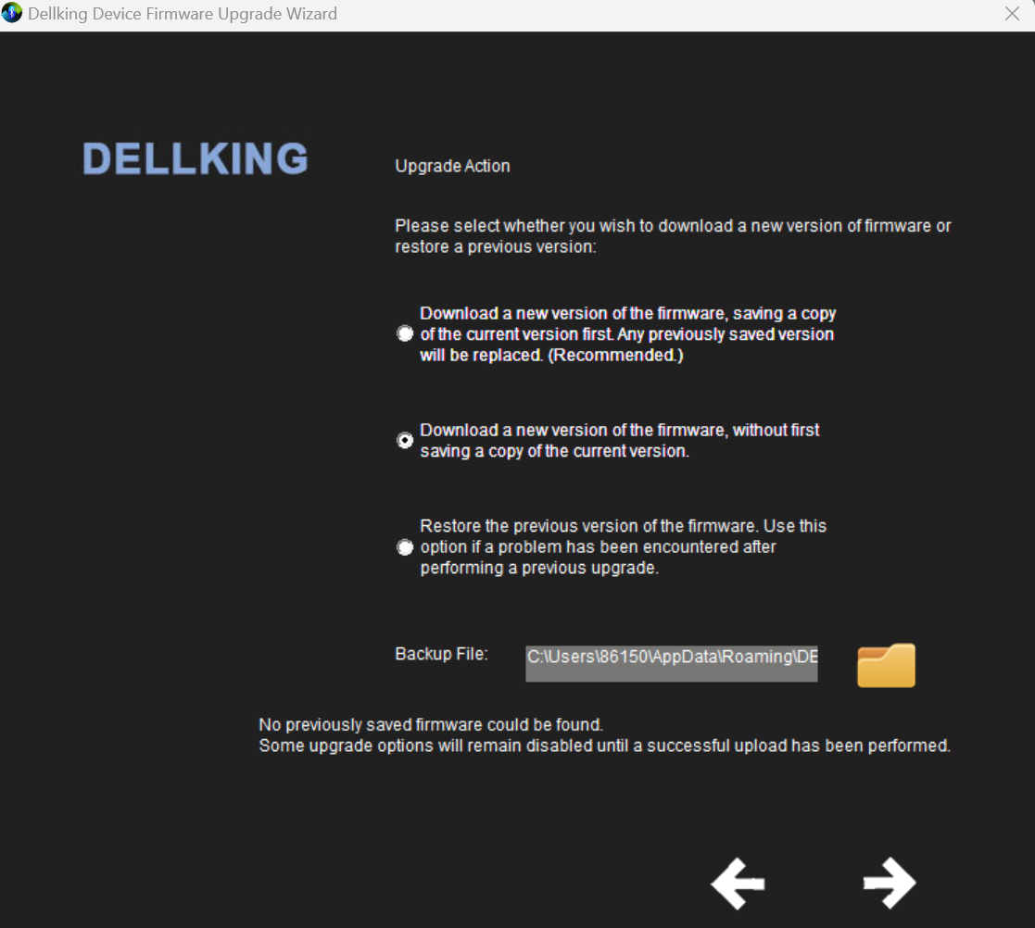
- A dialogue box pops up as below. Click ”folder icon” button to select the DFU file in the computer. Click “next”.
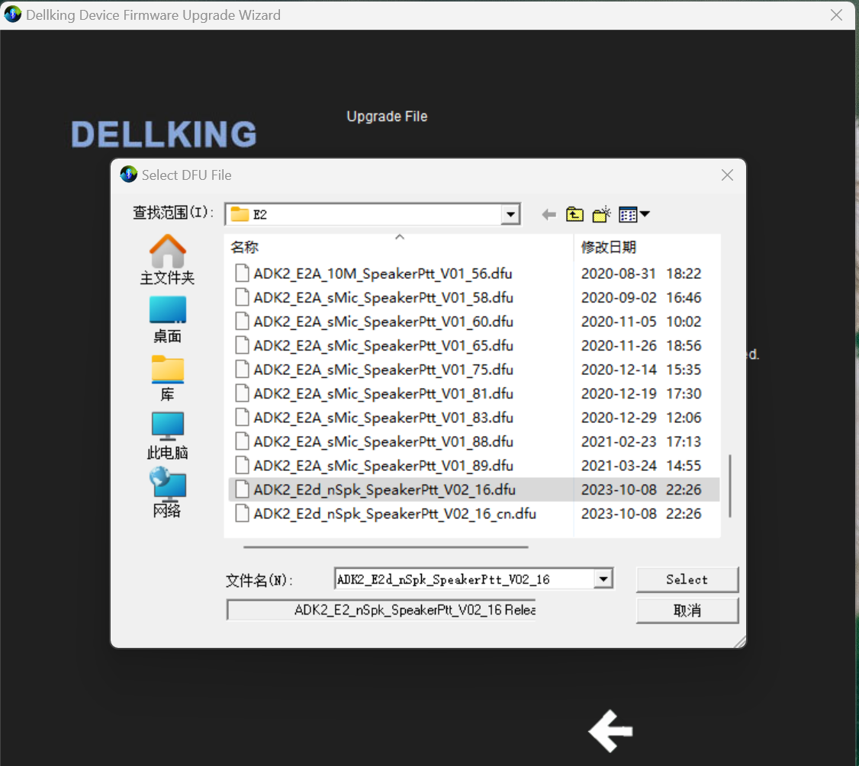
- Pop up the dialogue box below. It shows the descriptions about file before upgrading. Click “Next”.
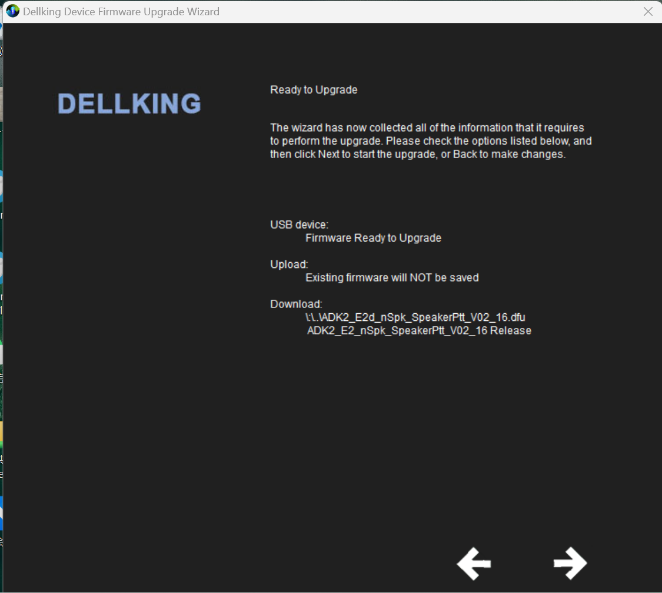

5）Pop up the dialogue box below. The programme is in the process of downloading (There is a “Stop” button that could end the current operation).
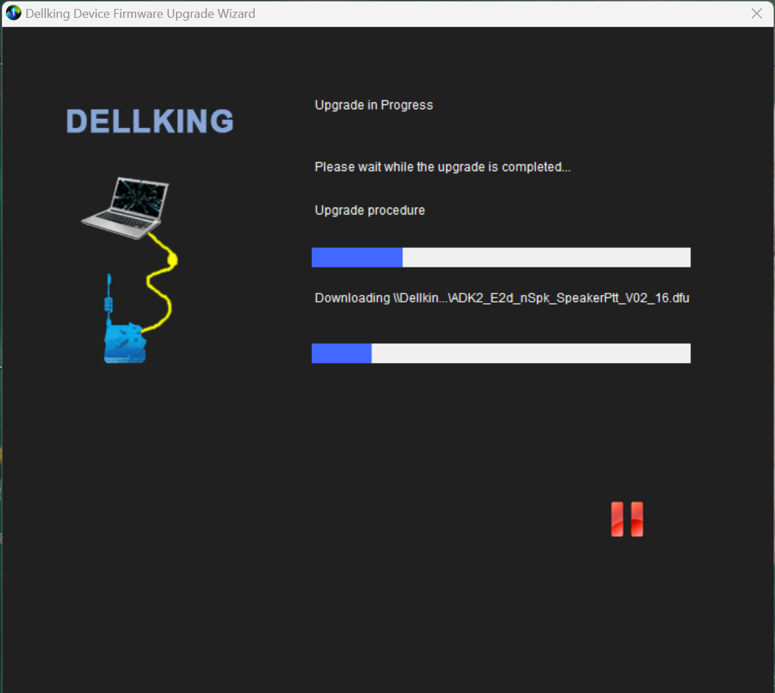
5）Pop up the dialogue box below. Show the upgrade success.
